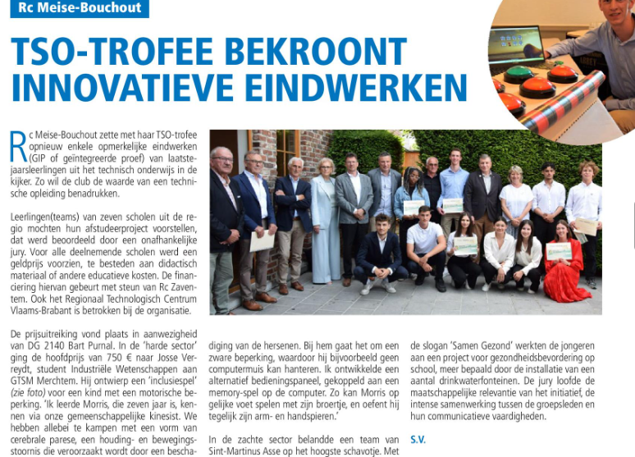

ROTARY CONTACT 2022

